SQL-HandsOn3

## Alberta “Albi” Kovatcheva

1. Write a query that Inserts a new actor into the database. Once you have completed the insert, write a query to view all information for that specific actor.

Query 1:

INSERT INTO sakila.actor

VALUES (201, "Keanu", "Reeves", "2021-07-03 07:57:00");

Query 2:

SELECT * FROM sakila.actor

WHERE actor_id = 201;

Results (1 row returned):

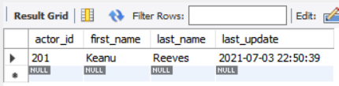

1. Write a query to Update the actor that you just inserted. Give your new actor a first_name of Emmy and a last_name of Rock. When you have completed that update, run another query to see your updated employee.

Tip! Make sure only to update your specific employee. Don't update all employees!

Query 1:

UPDATE sakila.actor

SET first_name = "Emmy", last_name = "Rock"

WHERE actor_id = 201;

Query 2:

SELECT * FROM sakila.actor

WHERE actor_id = 201;

Results (1 row returned):

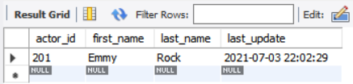

1. Write a query that finds all staff that do not have a value specified for password.

Query:

SELECT * FROM sakila.staff

WHERE password IS NULL;

Results (1 row returned):



1. Write a query that finds all staff's information that has a value for first_name and store_id.

Query:

SELECT * FROM sakila.staff

WHERE first_name IS NOT NULL and store_id IS NOT NULL;

Results (2 rows returned):



1. Write a query that updates all people with a Null value in the address2 column. If the district is Alberta, put address2 as Canada, and if the district is QLD, put Australia.

Tip! Even if you get an error because of permissions, include screenshots of your code and it won't count against you.

Query 1:

UPDATE sakila.address

SET address2 = "Canada"

WHERE district = "Alberta";

Query 2:

UPDATE sakila.address

SET address2 = "Australia"

WHERE district = "QLD";

Query 3:

SELECT * FROM sakila.address;

Results (603 rows returned):

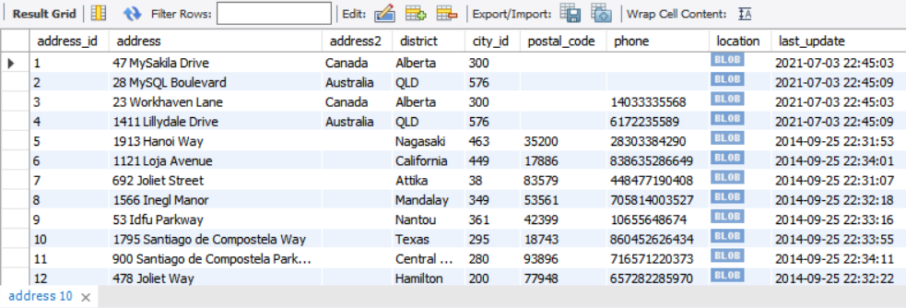

To execute these queries, I followed these steps suggested in StackOverflow:

1. Edit --> Preferences
2. Click "SQL Editor" tab and uncheck "Safe Updates" check box
3. Query --> Reconnect to Server // logout and then login
4. Execute the SQL query